Software Engineering (2)

Project Test

By

Ahmed Mohamed Elsayed Moustafa

A **JUnit** *test* is a method contained in a class which is only used for testing. This is called a Testclass. To define that a certain method is a test method, annotate it with the @Test annotation.



This method executes the code under test. We use an *assert* method, provided by JUnit, to check an expected result versus the actual result. These method calls are typically called *asserts* or *assert statements*.



There are two ways to perform unit testing:

1) Automated testing.

2) Manual testing.

The automated testing and manual testing will be performed on **DatabaseUtils** class since it contains all the methods that connect with the database.

1) Starting with **Automated Testing**

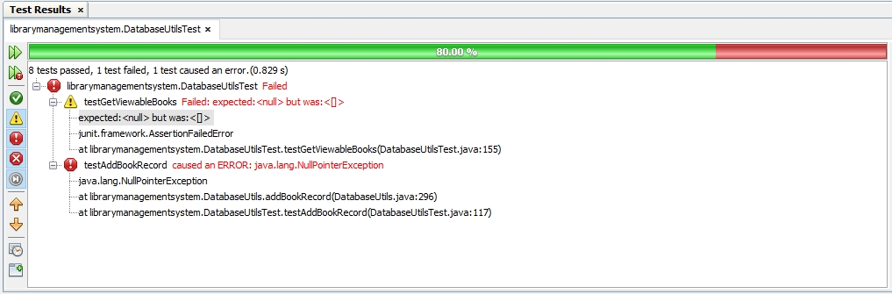We get the result in the Test Result console that all tests passed except for two tests

In the first test it failed due to a difference between **expResult** and **result** in the **assertEquals** method

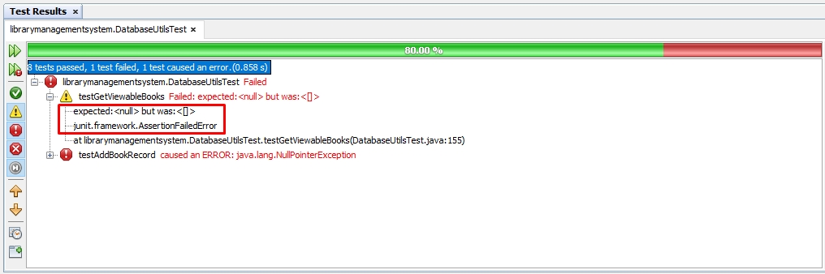

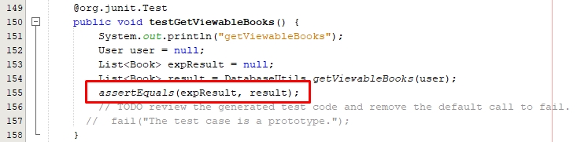

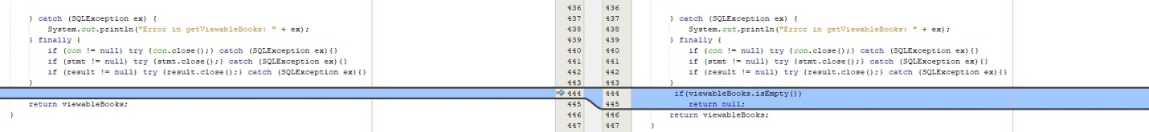This error will be fixed by creating an if statement that if **viewableBooks** list is empty then return null.

For the second error which caused by declaring the variable **book** by null in the testing case causing a **NullPointerException** which can be resolved by creating if statement in the beginning of **addBookRecord** method that if variable **book** is equal to null stop the **addBookRecord** method.

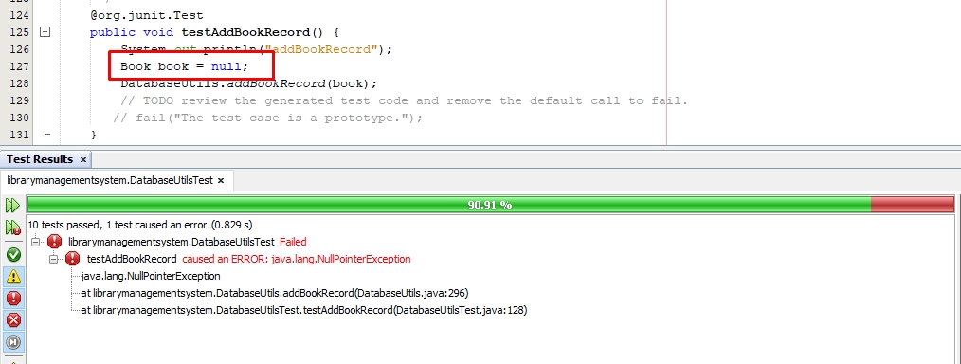

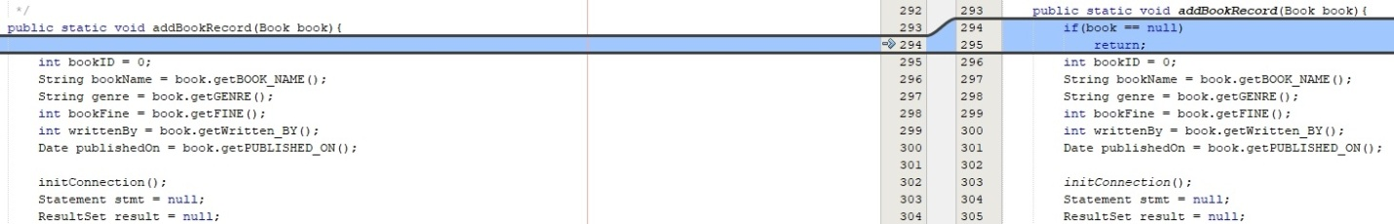

**DatabaseUtils** class Final Test with all successful tests after fixing them.

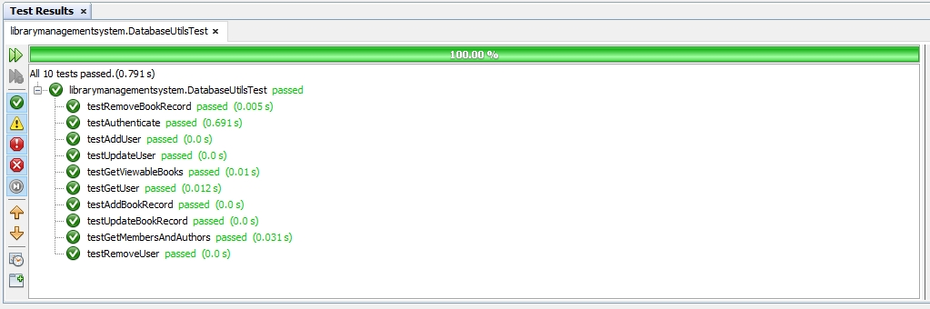

2) Manual testing

Test Authenticate method by adding random username and password

